
IT Manager & Cyber Security Lead
Job Pack
July 2026

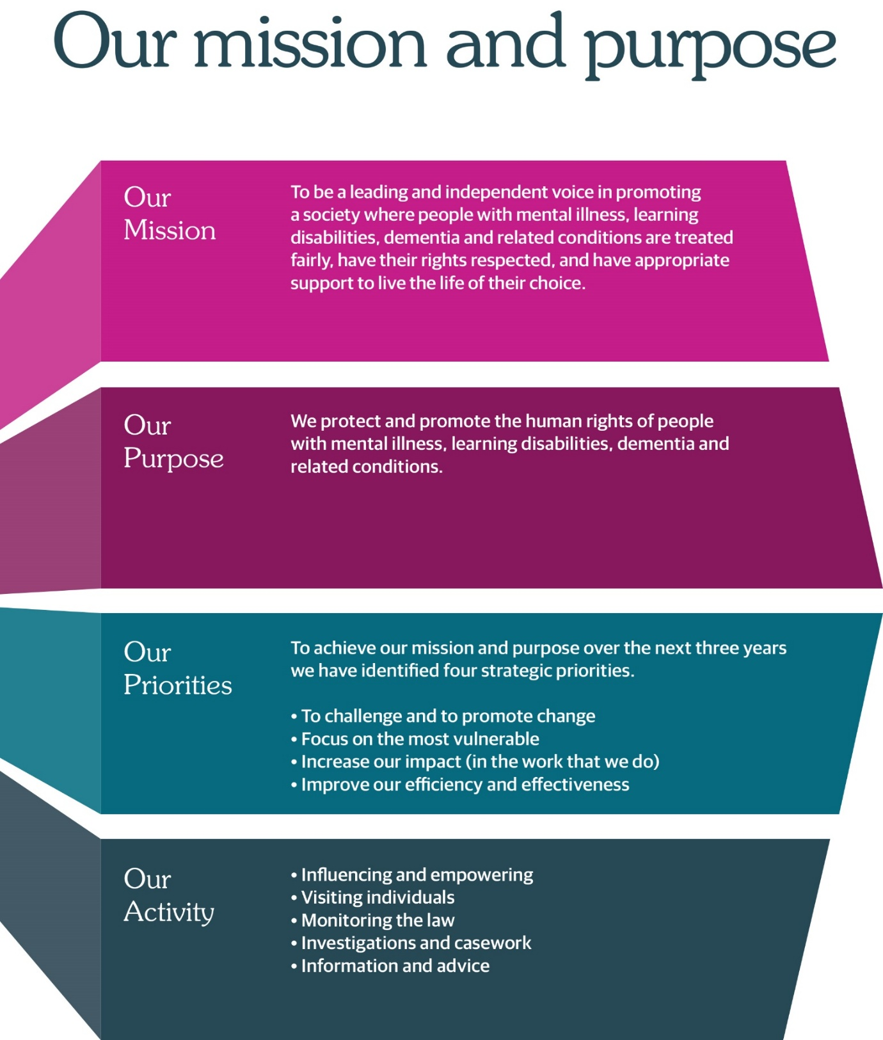

JOB ADVERT

Job title: IT Manager & Cyber Security Lead
Salary: £54,816 – £60,907 (£43,852 – £48,725 pro rata)
Contract/hours: Permanent, 28 hours per week (0.8 FTE)
Location: Thistle House, Edinburgh (hybrid working available)
Reports to: Head of Culture & Corporate Services
Direct Reports: Systems Analyst (1.5 FTE), Systems Administrator (2 FTE), Data
Intelligence & Research Officers (1.8 FTE)

About us

The Mental Welfare Commission for Scotland (the Commission) protects and promotes the human rights of people with mental illness, learning disabilities, dementia and related conditions. As an independent statutory body, we ensure that care, treatment and support across Scotland are lawful, ethical and person-centred.

We are recruiting an experienced and forward-thinking IT Manager & Cyber Security Lead to help us deliver secure, resilient and modern digital services that support our vital work. This is an exciting opportunity to join a values-driven organisation with a strong public-service ethos.

About the role

This is a brand-new leadership role within a small organisation, combining responsibility for day-to-day IT operations with strategic oversight of cyber security and related governance. You will manage our IT environment, support our staff, oversee suppliers, and lead the organisation’s cyber-resilience activities.

You will ensure our systems are reliable, secure and aligned with best practice principles (e.g. Cyber Essentials, the Scottish Public Sector Cyber Resilience Framework, National Cyber Security Centre Cyber Assessment Framework and ISO 27001). You will also play a central role in modernising our digital services and supporting the organisation’s wider strategic objectives.

About you

- Significant experience managing IT services in a small or medium-sized organisation
- Hands-on technical expertise across infrastructure, networks and Microsoft 365
- Experience leading cyber-security activities, including risk management and incident response
- Knowledge of Cyber Essentials and information-security best practice
- Experience supporting GDPR compliance
- Experience delivering digital transformation
- People management experience

What we offer
- Hybrid working
- Modern open plan office and facilities in the centre of Edinburgh
- Generous annual leave and NHS pension
- Opportunities for professional development
- A meaningful role contributing to human rights and public service in Scotland
- An organisation which is keen to continue to adapt and transform to meet the needs of the people it serves
- Supportive, values-driven organisational culture

How to apply

Application forms should be submitted to mwc.recruitment@nhs.scot by midday on Wednesday 12 August 2026. It is anticipated that interviews will take place w/c 17 or 24 August 2026. Informal enquiries to Ashley Dee, Head of Culture & Corporate Services via katrina.thomson3@nhs.scot.

JOB DESCRIPTION

Job title: IT Manager & Cybersecurity Lead
Hours: Permanent, 28 hours per week (0.8 FTE)
Salary: Grade 6
Location: Thistle House, Edinburgh (hybrid working available)

1 | Job Purpose
The IT Manager & Cyber Security Lead is responsible for the strategic and operational management of the organisation’s IT services, infrastructure, and cyber security posture. As a small public body, the role combines technical leadership, supplier management, cyber-risk oversight, and hands-on operational support.

The postholder ensures that systems are secure, resilient, and aligned with best practice principles.

2 | Role of the Mental Welfare Commission
 | The Mental Welfare Commission for Scotland (the Commission) protects and promotes the human rights of people with mental illness, learning disabilities, dementia and related conditions. As an independent statutory body, we ensure that care, treatment and support are lawful, ethical and person-centered.
3  4 | Dimensions  Reports to: Head of Culture & Corporate Services (Senior Information Risk  Officer [SIRO])  Direct Reports: Systems Analyst (1.5 FTE), Systems Administrator (2 FTE), Data  Intelligence & Research Officers (1.8 FTE)  Teams: Member of extended executive leadership team (EELT)  Key relationships: Information Governance Manager (Data Protection Officer [DPO])  Workforce size: Approximately 80  Annual budget: Approximately £7m (2026/27)  Key result areas – Summary

IT Management

- Lead the planning, delivery, and continuous improvement of all IT services.
- Manage the organisation’s IT infrastructure, networks, cloud services, and end-user devices.
- Oversee IT suppliers, contracts, SLAs, and procurement activities.
- Develop and maintain a digital transformation strategy, roadmap, and annual IT budget.
- Ensure reliable operation of business-critical systems, including legacy applications.
- Provide technical leadership and hands-on support where required.
- Leadership of multidisciplinary team.

Cyber Security Leadership

- Act as the organisation’s Cyber Security Lead, responsible for cyber-risk management and resilience.
- Maintain Cyber Essentials (CE) certification and drive continuous improvement.
- Align policies and controls with best practice requirements, including National Cyber Security Centre Cyber Assessment Framework (NCSC CAF), ISO 27001 and the Scottish Public Sector Cyber Resilience Framework.
- Lead the development, testing, and maintenance of the Incident Response Plan.
- Oversee vulnerability management, patching, MFA, backups, and access control.
- Coordinate external penetration testing, CE+ assessments, and independent audits.
- Monitor cyber threats and ensure appropriate mitigations are in place.
- Provide cyber-security advice to senior leadership and act as technical advisor to the SIRO.

Information Governance & Compliance

- Support compliance with GDPR, UK Data Protection Act, and handling of special category data.
- Work closely with the Information Governance Manager (DPO) on data-security matters.
- Maintain the organisation’s information-security policies, procedures, and risk register.
- Ensure secure configuration, logging, monitoring, and incident reporting.
- Support business continuity and disaster recovery planning.

Governance, Reporting & Assurance

- Provide quarterly cyber-risk and IT performance reports to the Executive Leadership Team (ELT).
- Ensure appropriate separation of duties through external assurance and independent testing.
- Lead supplier assurance checks and ensure third-party security compliance.
- Contribute to internal and external audits, including cyber-resilience assessments.

Training & Culture

- Lead cyber-security awareness training for all staff.
- Promote a culture of security, resilience, and good digital practice.
- Provide guidance on secure working, data handling, and emerging threats.

5 Key Challenges of the Role

- Balancing IT operations with cyber-security leadership in a small organisation.
- Managing legacy systems while driving modernisation.
- Ensuring compliance with public-sector cyber-resilience standards.
- Providing assurance and governance despite limited internal resources.
- Acting as both strategic lead and hands-on technical support.

6 Person Specification – Qualifications, Skills & Knowledge

Essential:

- Degree or equivalent qualification in IT, computer science, cyber security or related discipline; alternatively equivalent and demonstrable experience.
- Cyber security certification (such as CISP, CISM or ISO 27001 lead implementer or auditor).
- Proven experience managing IT services in a small or medium-sized organisation.
- Strong technical background across networks, cloud services, Microsoft 365, and infrastructure.
- Experience leading cyber-security activities, including incident response and risk management.
- Knowledge of CE, ISO 27001, NCSC CAF and public-sector cyber-resilience requirements.
- Knowledge of cloud security, identity management, and SOC services.
- Experience managing suppliers, contracts, and outsourced IT services.
- Understanding of GDPR, data protection, and handling of special category data.
- Ability to work independently and balance strategic and operational responsibilities.
- Strong communication skills, able to explain technical issues to non-technical audiences.
- People management experience.

Desirable:

- Experience in a public-sector or regulated environment.
- Experience with business continuity and disaster recovery planning.

PERSON SPECIFICATION

 | Essential | Desirable | Assessment Method (A / I)
Qualifications | Degree or equivalent qualification in IT, computer science, cyber security or related discipline; alternatively equivalent and demonstrable experience. | – | A
Qualifications | Cyber security certification (e.g., CISSP, CISM, ISO 27001 Lead Implementer or Auditor). |  | A
Experience | Proven experience managing IT services in a small or medium-sized organisation. | Experience in a public-sector or regulated environment. | A/I
Experience | Strong technical background across networks, cloud services, Microsoft 365, and infrastructure. |  | A/I
Experience | Leading cyber-security activities, including incident response and risk management. |  | A/I
Experience | Managing suppliers, contracts, and outsourced IT services. |  | A/I
Experience | People management experience. |  | A/I
Knowledge | Cyber Essentials, ISO 27001, NCSC CAF, and public-sector cyber-resilience requirements. |  | A/I
Knowledge | Cloud security, identity management, and SOC services. |  | A/I
Knowledge | Understanding of GDPR, data protection, and handling of special category data. |  | A/I
Skills | Ability to work independently and balance strategic and operational responsibilities. | Experience with business continuity and disaster recovery planning. | A/I
Skills | Strong communication skills, able to explain technical issues to non-technical audiences. |  | A/I

JOB INFORMATION

Headquarters | Thistle House, 91 Haymarket Terrace, Edinburgh, EH12 5HE (hybrid working options)
Leave | Annual Holidays  The annual entitlement for full time posts is 25 days per year, rising to 30 days after 10 years’ relevant service. (NHS and local authority service is counted as relevant service). Leave entitlement is pro-rata for part-time posts.  General/Public Holidays  Public and privilege holidays total 11.5 days per leave year, 6 of these are on set dates and the remainder can be taken as required.  For part time posts, the public/privilege holiday entitlement is pro-rata to full time equivalent.  The leave year runs from 1 April to 31 March.
Superannuation | NHS Pension Scheme is available to all employees subject to scheme rules.  Please click here for current contributions details.  The employer currently contributes an amount equal to 20.9% of pensionable pay into the scheme on members’ behalf.
Staff Benefits | Through the Commission employee Benefits scheme there is access to a wide variety of offers and discounts from the UK’s most popular retailers and service providers. The current provider is EdenRed. There is also access to, My Gyms discount site, the UK's largest network of gyms, studios, fitness centres and sports clubs across the UK with discounted membership offers. A comprehensive Employee Assistance Programme is also available and access to a Cycle to Work Scheme. (The Commission reserves the right to withdraw, amend the schemes and change providers as appropriate)
Our values | The Commission operates a set of internal values for employees.
Performance, Learning and Development | There is a performance development system in operation within the Commission. Progression through the salary scale is subject to satisfactory performance.
Data protection | The information you provide on the application form and any supplementary forms will be used to assist in the process of recruitment and selection in accordance with the Policy of the Mental Welfare Commission.  If you are successful in your application the information you provide will be used for HR and Payroll purposes. By signing the declaration section of the application form it is understood that you consent to the use and storage of your personal information for the above stated purposes.
Work outside the Commission | It is important to identify and minimise any conflicts of interest that could prevent staff from making fair and objective judgements or could be perceived as doing so by people with lived experience and carers, practitioners and the public. Details are contained in the Commission’s Conflict of Interest Policy. Please note that employees may not be members or employees of the Mental Health Tribunal for Scotland while working for the Commission.
Probationary period | The post requires a 3 months’ probationary period.
Disclosure Scotland | The post requires a Disclosure Scotland Basic certificate and self-declaration.
Occupational Health Screening | Any offer of employment is subject to satisfactory Occupational Health clearance. The successful candidate will be asked to complete a Pre-Employment Health Questionnaire. NHS Lothian Occupational Health will make an assessment on your fitness to carry out the post based on the information contained within the questionnaire. In certain circumstances further information is required before clearance can be given and Occupational Health may contact you by telephone or request that you attend for an appointment. Clearance must be obtained before any new employee commences employment. Clearance may be subject to you attending for a post-Employment appointment and it is vital that you attend this appointment if required.
Complaints | The Commission has a Complaints Handling Procedure. All applicants have access to it if they feel they have been unfairly treated during the recruitment and selection process. External applicants should direct any concerns to the Human Resources department and internal applicants have recourse to the Commission’s Grievance Procedure.
Equal opportunities | The Commission is an equal opportunities employer.
Feedback | We do recognise the time and effort it takes to apply for a position. Following the short-listing process, you will be notified about the outcome of your application by email.

How to Apply

The Mental Welfare Commission encourages applications from all sections of the community.

We aim to have a workforce which represents the wider society that we serve and therefore encourage applications from people of all backgrounds and under-represented groups.

We hope the information we have provided will encourage you to find out more about this opportunity.

If you wish to view more information on applying, please visit our website:
Work with us | Mental Welfare Commission for Scotland (mwcscot.org.uk)

